Dear Parents and Carers,

Come and join us at our major school production this November as we present: Disney’s The Little Mermaid the Musical.
Join us for a magical musical adventure with some of Disney's most beloved characters. Will Ariel the mermaid find true love with Eric, or will the evil sea witch Ursula trap her voice and soul forever? Featuring all the songs from the beloved original animated movie and a script full of charm and wit, this is a production that will bring joy to all. Suitable for all ages of humans, merfolk and other sea creatures!
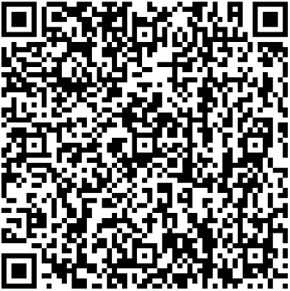
Performances in Constance Green Hall.
Wed 22 Nov at 7pm
Thu 23 Nov at 7pm
Fri 24 Nov at 7pm
Sat 25 Nov at 2pm, Matinee
Sat 25 Nov at 7pm

The box office for tickets to the show can be accessed by scanning the attached QR code or clicking this link: www.ticketsource.co.uk/st-aidans-church-of-england-high-school
We look forward to welcoming you to an evening full of magic and charm.

Andrew MacCallum
Director/Producer Disney’s The Little Mermaid

